

ICIS DMR Plug-In Starter Kit

Installation and Administration Guide

EN-Node

Version: 2.0

May 31, 2012

Logo

1368 How Lane

North Brunswick NJ 08902

[www.enfotech.com](http://www.enfotech.com)

Restriction on Use and Disclosure of Document Information

This document includes data that should not be disclosed outside the business entity for which it was intended, indicated as the recipient on this title page. The entire document is copyrighted by enfoTech and is protected under the US copyright law and international treaties. No part of this document may be reproduced or transmitted in any form or by any means, electronic or mechanical, for any purpose, without express written permission from enfoTech & Consulting Inc.

Copyright © 2001 – 2012 by enfoTech & Consulting Inc. All Rights Reserved.

Revision History

|  |  |  |  |  |
| --- | --- | --- | --- | --- |
| Version | Date | Created By | Reviewed By | Description |
| 1.0 | 10/20/2010 | Charlie Tsai | Doug Timms |  |
| 2.0 | 05/31/2012 | Charlie Tsai |  |  |
|  |  |  |  |  |
|  |  |  |  |  |

Tables of Contents

1. Document Purpose 4

2. Plug-In Overview 4

3. Supported Schemas and Payloads 5

4. Prerequisites 5

5. Installation Package 5

6. Installation Instruction 5

6.1 Create a ICIS-DMR staging database 5

6.2 Create a ICIS Domain in the Node Administration Console 5

6.3 Modify ICISOperationConfig.xml 6

6.4 Create a solicit web service with the SubmitICISDMR plug-in 6

6.5 Configure SubmitICISDMR plug-in for Operation Manager 6

7. Test ICIS-DMR Plug-In 7

7.1 Access Operation Manager 7

7.2 Call Operation to Generate ICIS-DMR Submission File 7

7.3 Call Operation to Submit ICIS-DMR Data to EPA 7

# Document Purpose

The purpose of this document is to provide guidance on the setup, use, and maintenance of the EN-Node ICIS-DMR Plug-ins.

# Plug-In Overview

The following diagram outlines the ICIS-DMR plug-in and its interaction with an existing NPDES data management system and EPA.

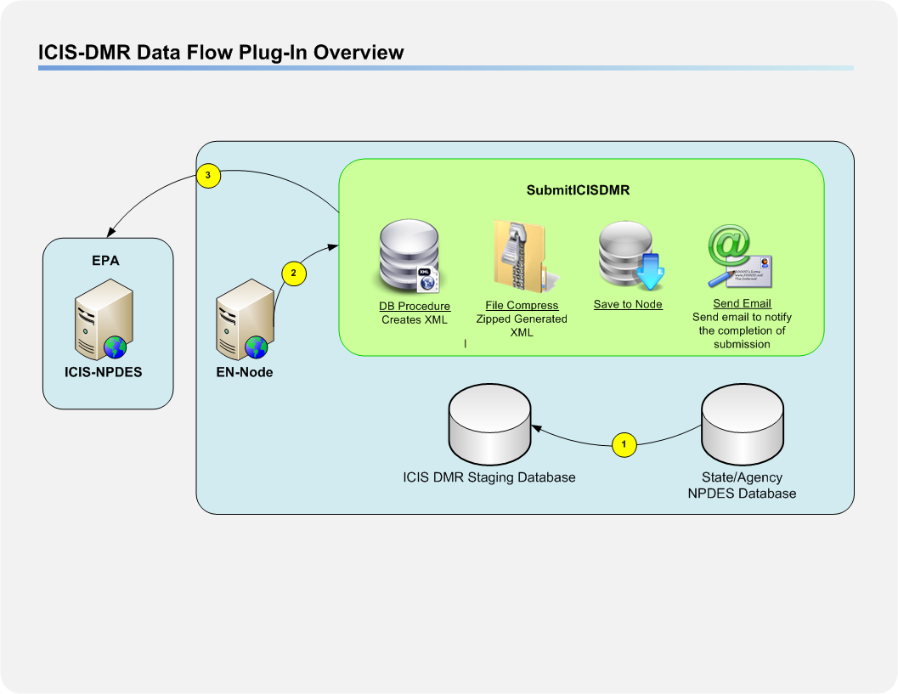

***Figure 1: ICIS-DMR Data Flow Plug-Ins Overview***

In the following sections and diagram below, the ICIS-DMR Plug-in is described in detail.



The State or Agency will populate the ICIS Staging Database.

The EN-Node Invokes the SubmitICISDMR plug-in though Node Operation Manager. This process includes the following steps:

1. The plug-in obtains available ICIS-DMR data from the ICIS staging database.
2. The plug-in executes a Database stored procedure component to generate an ICIS DMR XML file.

The plug-in then compresses the XML to a zip file, and submits the result to EPA. The implementation details are described here:

1. The XML file generated during the previous step will be compressed and saved to the node database
2. An Authenticate web service call will then be invoked with NAAS account information. The NAAS account information is part of the passing parameters to the plug-in.
3. If the Authenticate is successfully executed, a valid security token will be obtained.
   1. A failed attempt of Authentication will end the process and will be logged with a failed status in EN-Node
4. The security token and the compressed file are delivered to CDX via a web service Submit call.
5. The successful result of the submission is determined by obtaining the transaction id.
6. The transaction id will be saved.

# Supported Schemas and Payloads

* Schema(s): 2.0
* Payload(s): DischargeMonitoringReportSubmission



# Prerequisites

* EN-Node application is installed
* A local ICIS-DMR data source exists in SQL Server format

# Installation Package

* ICISDMRStagingDB.zip
* ICISOperationConfig.xml

# Installation Instruction



## Create a ICIS-DMR staging database

Before any ICIS-DMR plug-in installation, it should have an ICIS-DMR staging database created.

1. Log in to MS SQL Server as an administrative account.
2. Find the **ICISNPDESStagingDB.zip** file and unzip it.
3. Open the file into MS SQL Server.
4. Make sure to change the directory within the script to the desired database location before executing **ICIS_STG_v2.sql**. This script creates the ICIS staging tables.

CREATE DATABASE [ICIS_STG_S] ON PRIMARY

( NAME = N'ICIS_DMR_STG', FILENAME = N'F:\MSSQL\Data\icis_stg_s.mdf' , SIZE = 132672KB , MAXSIZE = UNLIMITED, FILEGROWTH = 1024KB )

LOG ON

( NAME = N'ICIS_DMR_STG_log', FILENAME = N'F:\MSSQL\Data\icis_stg_s_1.ldf' , SIZE = 35712KB , MAXSIZE = 2048GB , FILEGROWTH = 10%)

**\*NOTE:** If a different ICIS-NPDES related Plug-In (ie. Unpermitted Facility or Inspection) is already configured, you do not need to execute the ICIS_Stage_DB.sql.

1. Execute **ICIS_OBJ_v2.sql**. Upon successful execution, the results will be as follows:

* ICIS-NPDES staging table will be created
* ICIS-NPDES views will be created
* ICIS-NPDES stored procedure will be created

## Create a ICIS Domain in the Node Administration Console

In order to create an operation using SubmitICISDMR plug-in under the EN-Node, you must first create a Domain. The Domain is logical grouping of operations.

1. Log into the Node.Administration console
2. Click the “New Domain” link and fill in the following information
   1. **Domain Name:** ICIS
   2. **Domain Administrator:** admin (or any other accounts you would like to manage the ICIS file creation process)

## Modify ICISOperationConfig.xml

1. Find the following Section in the ICISOperationConfig.xml

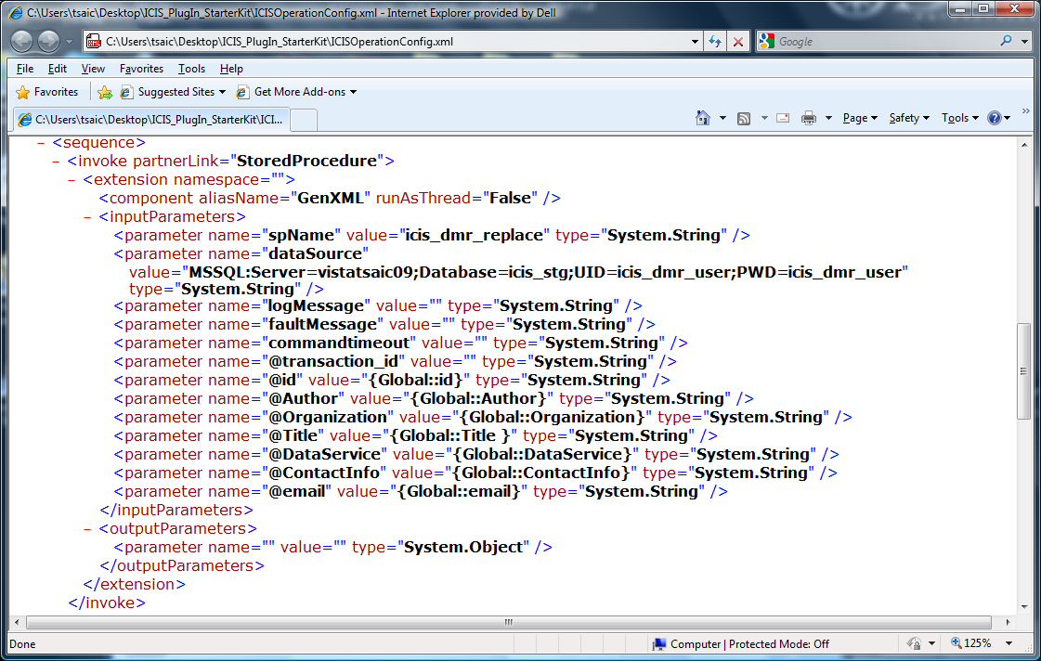

1. Modify the value for dataSource to connect to your ICIS-DMR staging database.

## Create a solicit web service with the SubmitICISDMR plug-in

1. Locate the Node Domains webpart from the Node Dashboard.
2. Under the Node Domains webpart, click the “Go to Operations” link for the ICIS Domain
3. Click the “Create Operation by XML” button
4. When prompted, locate and upload the ICISOperationConfig.xml file.
5. Click the “Save” button

## Configure SubmitICISDMR plug-in for Operation Manager

1. Return to the Node Dashboard screen
2. Under the Node Configuration webpart, click the icon link for (7) Operation Manager
3. Under the Operation Manager screen click the “Add Operation” button
4. Under the Configure Operation screen:
   1. Select Operation Name = SubmitICISDMR
   2. Check Enable Generate, Enable Submit, and Enable GetStatus options
   3. Under the Submit section:
      1. Enter in URL as following:
         1. <https://testngn.epacdxnode.net/ngn-enws20/services/NetworkNode2ServiceConditionalMTOM>

(testing endpoint)

* + - 1. [https://cdxnodengn.epa.gov/ngn-enws20/services/NetworkNode2ServiceConditionalMTOM](https://cdxnodengn.epa.gov/ngn-enws20/services/NetworkNode2ServiceConditionalMTOM%20)   
         (production endpoint)
  1. Enter in User Name = Enter NAAS assigned User ID
  2. Enter in Password = Enter NAAS assigned Password
  3. Enter in Domain Name = default
  4. Enter in Data Flow Name =ICIS
  5. Under GetStatus section:
     1. Completed Status = Completed
     2. Failed Status = Failed
  6. Click “Save Operation” button

# Test ICIS-DMR Plug-In

If the ICIS-DMR staging database has been successfully populated by a local ICIS-DMR data source from which you will generate ICIS-DMR XML files, please follow the steps below to generate the ICIS-DMR submission file from the ICIS-DMR staging database and submit to EPA:



## Access Operation Manager

1. First log into the Node Administration application.
2. Under the Favorite Links webpart, click the “Operation Manager” link.

## Call Operation to Generate ICIS-DMR Submission File

1. From the Selected Operation dropdown, select the “SubmitICISDMR” operation.
2. Click on the “Generate” button to generate the ICIS-DMR XML submission file from the ICIS-DMR staging database.
   1. Generation of the ICIS-DMR XML submission file may take some time, so the file may not be available

## Call Operation to Submit ICIS-DMR Data to EPA

1. Once the ICIS-DMR XML is generated, you can find it from the data grid.
2. From the grid, check the checkbox for the generated ICIS-DMR Data file.
3. Click the “Submit” button to submit the ICIS-DMR file to the EPA CDX Node.